KIT519 Software Engineering and HCI

Assignment 1: SDLC and Requirements Engineering - Individual component

Group 21

Individual Component
Submitted by

Ravikumar Savani 685167

Analysis of the Requirement Specification
The project on a Smart Bin System at the University of Tasmania is a project aimed at modernizing the current waste management practice at the University with high-end technologies such as sensors and cameras for the fill levels of the bins and contamination. With the university's drive toward sustainability, the project will seek out new methods for managing waste efficiently with minimized environmental impact.

Overview of the Specification Document
the main hardware and software components used in the Smart Bin System will come out. The hardware involves the sensors and cameras integrated within the existing bin infrastructure, designed to pick up waste contamination and levels of filling without interfering with one's privacy. The software element concerns the monitoring system that provides real-time data to the infrastructural team in view of proper decision-making for both waste collection and its management in relation to contamination. This is in addition to the specification, which notes how privacy and data security will be achieved in such a way that the system will not capture information that identifies people. This relates well with modern data protection principles that have been very paramount in the design of systems where potentially sensitive information could be collected (Cavoukian, 2009). There is also a project scope for user feedback and reporting, analytics, and an enormous maintenance scheduling system.

Key Project Requirements and Constraints
Most fundamental for the Smart Bin System is the need to improve efficiency in waste management on the university's campus. It makes sure that technology is installed which will automatically sense contamination or whether bins are full, thus doing away with manual checks (Kofoworola and Gheewala, 2008). The system should alert the infrastructure team in real time; otherwise, small issues could turn into bigger challenges, such as overflowing wastes or material contamination, considering that recyclable materials are mixed at source.
The solution has a key project constraint: it needs to be user-friendly and safe. The system should focus on maintaining data privacy—no identifiable information should be captured, and data sent to the monitoring system must be encrypted. This also meets the current requirements with respect to data security for the IoT system, which needs to have strong encryption and access controls for user data (Roman et al., 2013). Besides, the system must be scalable as university waste management infrastructure expands in the future. This involves giving the software the ability to cater for more increased data loads by incrementing the number of bins each time and also ensuring that the hardware is stable enough to support normal usage in varying environmental conditions. Realisation of this project will, therefore, be based on taking into consideration the requirements and constraints of the Smart Bin System well in perspective with the need to achieve effectiveness and sustainability of the system over the long term.

Phases of the Chosen SDLC
The Smart Bin System project at the University of Tasmania adopts the Agile SDLC and encompasses six key phases: Planning, Design, Implementation, Testing, Deployment, and Maintenance. Each of the phases will be important in ensuring that the system is developed and deployed successfully, with its own specific goals and deliverables to guide the project through its life cycle.
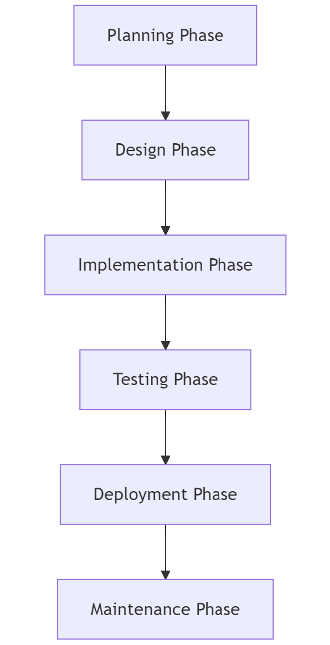
Figure 1 Phases of SDLC

Phase 1: Planning
Goals:
The Planning Phase is very crucial, as it lays down the ground base of the project. The main objectives that are achieved in this phase include detailed requirements gathering, defining the project scope, and feasibility analysis. The close working with key stakeholders within the university—that is, the sustainability and infrastructure management teams—helps in determining needs and expectations from the smart bin system. The resources, budget, and time to complete the project are also identified in this phase.
Deliverables:
- Project Plan: The project plan is an exhaustive document that describes the project in terms of its objectives, timelines, resources, and milestones. This would, in fact, be a roadmap for the entire development process and would give an idea quite lucidly about what is to be done and when it is to be accomplished.
- Feasibility Report: The feasibility report determines the technical, financial, and operational viability of the project. This goes a long way in ascertaining the viability of the project and worthiness of pursuing it, since the analysis of available resources and possible risks to be incurred in terms of outcomes expected can be projected (Kerzner, 2022).
Requirement Specification: This is the document that specifies the various functional and non-functional requirements of the Smart Bin System, such as real-time monitoring, contamination detection, and privacy controls. The requirement specification is very important for ensuring that all the project stakeholders get a common understanding of what the system is going to deliver (Wiegers & Beatty, 2013).

RTM for Planning Phase
Requirement ID | Requirement Description | SDLC Phase | Deliverable | Verification Method
R1 | Gather detailed requirements from stakeholders | Planning | Requirement Specification | Stakeholder Review
R2 | Define project scope and objectives | Planning | Project Scope Document | Project Scope Approval
R3 | Conduct feasibility study | Planning | Feasibility Report | Feasibility Review
R4 | Develop project plan including timeline and resources | Planning | Project Plan | Project Plan Review

Critique on SDLC Techniques

Agile vs. Waterfall
Agile Methodology: Agile is an iterative and incremental approach emphasizing flexibility, collaboration with customers, and rapid delivery of their needs. It would be particularly useful for projects where changes are expected or the requirements are not understandable at the initial stage of a project (Kuhrmann et al., 2021). Since it is very adaptive, Agile makes it easy for refinement at each step, according to the needs of stakeholders. Thus, it has a great fit in innovative projects like the Smart Bin System, where technology may change its integration or user needs may change during project development.
Waterfall Methodology: Waterfall follows a linear and sequential model; it is a very strict phase-by-phase manner, and one cannot proceed to the next phase without completing the previous. It is most applicable to projects with rigidly defined requirements and minimum expected changes over the lifetime of a project (Hossain, 2023). Due to the deterministic nature of Waterfall, it ensures maximum documentation and sharp milestones of benefit; thus, it is most beneficial in instances where the project has to meet certain regulatory requirements or under some confined scope.

Comparison and Analysis:
- Flexibility: Agile is much more flexible than Waterfall. On the flip side, due to Waterfall's inflexible framework, it becomes very hard to adapt the changes when the project has already been executed after the planning and requirement phase. Due to the innovative nature and possibility of a dynamic change in the requirements for this Smart Bin System, flexibility coming from Agile is highly advantageous.
- Stakeholder Involvement: Unlike Agile, which keeps the stakeholders involved throughout the incremental development cycles and ensures that a product developed will meet the users' expectations, Waterfall is highly concerned with stakeholder engagement during the planning phase. These may not be practical, hence mismatch of the resultant product with the users' expectations in case of a requirement change.
- Risk Management: Agile's iterative testing and development support the identification and dealing with risks at an early stage; therefore, it is more appropriate to be used for projects which have either uncertain or evolving requirements. On the other hand, the more sequential approach of design, development, and only then testing and validation in the Waterfall model may expose the project to more serious risks, as during the testing and validation stage, there is no earlier testing done, but it is carried out after the whole system is developed.

Conclusion:
Although Waterfall is structured in a way that makes it help in getting clear documentation and milestones, its rigidness does not make it fit for the Smart Bin System project. The reason is that changes are expected in requirements; thus, frequent feedback from stakeholders becomes something of prime importance. Agile wins here due to adaptability, stakeholder collaboration, and managing risks iteratively.

